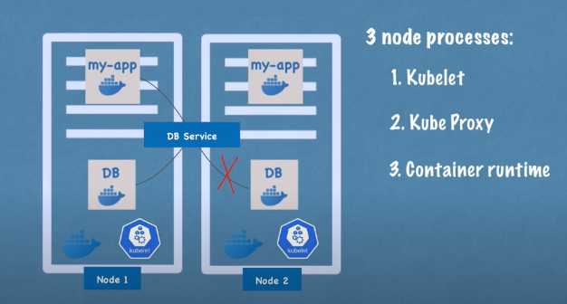

two types of nodes

1. master

2.worker nodes[communication b/w the works nodes is services]

workers nodes

-->3 process mst be installed on every node.

1. container runtime:

responsible for running containers(docker,containered,cri-o,)

2. kubelet: (get request form the schedular)
it is the responsibility to start the pod with the container
kubelet interacts with the both container and the node.
.
assinging resources from that node to the container.like(cpu,)

3.kube-proxy: it is a network proxy,forwarding requests from kubernetes service to pods.
Master node:
4 process run on every master node.
Api server: anything you want to do on kluster the request 1st goes to the api server it validates the request then only forward to the other process.
it is like a cluster gate way .it gets the initial request for any updates.
User wants to deploy a new application into a kubernetes cluster.request 1st interacts with the api server.
Scheduler: scheduler desides on which node the pod will be scheduled. .it validates how much cpu and RAM req to the container.then it go through the worker node and see the available resource.depending on it scheduled.(get reqsts from CM)

Controller manager :detects stage changes,when pods die it detects the state changes and tries to recover the state of the cluster as soon as possible.(make requstes to schedular).

ETCD: CLUSTER CHANGES GET STORED IN THE ETCD.
HOW SCHEDULAR KNOWN WHAT RESOURCES AVAILABLE
DID THE CLUSTER STATE CHANGE.
THE CLUSTER HEALTHY OR NOT.
IT IS A KEY VALUE STORE OF THE CLUSTER STATE
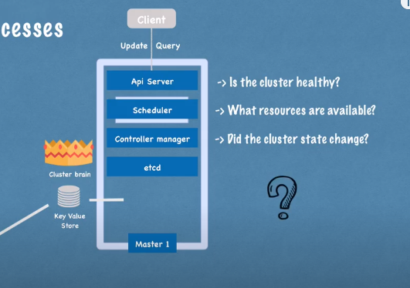
IT IS A KEY VALUE STORE OF THE CLUSTER STATE .

